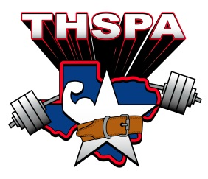

ACADEMIC ALL STATE 2016
SECOND TEAM
Athlete | School
Matt Coker | Caddo Mills High School
Trystan Banks | Miles
Roy Abanonu | Plainview High School
Brandon Michael Melton | Quinlan Ford H. S.
Cody Armstrong | Chico High School
Quinten Franks | Lubbock-Cooper
Hunter Duplessis | San Antonio Cole
Tony Tapia | College Park
Axel Morfin | College Park
Lucas Pinnell | Winnsboro High School
Lloyd Allums | Beaumont Central
Esteban Lopez | Andrews High School
Guillermo Saldana | Carrollton RL Turner
Nicholas Talamantez | Southwest High School
Juan Mireles | Port Isabel High School
David Luna | Laredo Johnson
Avery Srebalus | East Bernard ISD
Daniel Hernandez | Taylor High School
Israel Alfaro | Weslaco East High School
Eric Shaw | Lone Oak ISD
Cal Bauer | Navasota High School
Bobby Hanson | Axtell
Kris Hernandez | Lamesa
Alcus Carter | Victoria West HS
Tate Richards | Springlake-Earth ISD
Bryan Tran | Highland Park ISD
Noel Ybarra | Pecos High
Nathan Besch | Weimar High School
Mitch Hardaway | Atlanta

