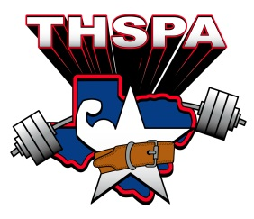

ACADEMIC ALL STATE 2016
HONORABLE MENTION
Athlete | School
Jason Marroquin | Axtell
Jame Phillips | Crane High School
Kory Taylor | Victoria West HS
David Smith | A.C. Jones High School
Jesse Simien | Winnie East Chambers
Juan Mancilla | Nocona
Andrew Hlavinka | East Bernard ISD
Waylon Hansen | Highland Park ISD
Devin Novak | Highland Park ISD
Nelson McGrew | Pecos High
Adrian Hernandez | Grape Creek High School
Jason Ayers | Lampasas High School
Kaylond North | Dickinson
Zachary Gartman | Cross Plains High School
Jacob Guzman | Hermleigh
Damon Jones | Olton
Brysien Cross | Chapel Hill High School
Brody Schleeter | Lubbock-Cooper
J. Paul Axtell | Olney
Lorenzo Sanchez | Taylor High School
Channing Christophe | Killeen Shoemaker
Jonah Masters | San Antonio Cole
Hunter Dollery | Victoria West HS
Drew McVicker | Olney
Mauro Vargas | Juarez Lincoln HS
Jared Norman | Wills Point High School
Christopher LeBeouf Jr. | Pecos High School
Benjamin C. Madrid | Pecos High School
Coty Beard | Monahans
Zachary Perry | Arlington Heights
Leo Rosales | Rusk High School
Jacob Mclean | Scurry-Rosser High School
Ethan Kelly | Scurry-Rosser High School

